Elementary Geometry

Definition
# Source: AI Source: Provided by: [Data Path: Persons Table -> ID Column: 1, Name_En Column: Motasem Essam] -> From: [ChatGPT] on [7/20/2026]
Elementary Geometry is the branch of geometry that studies basic geometric objects, figures, measurements, properties, and relationships using fundamental geometric concepts and methods.
It primarily deals with objects such as points, lines, angles, segments, triangles, quadrilaterals, polygons, circles, and basic three-dimensional solids.
Elementary geometry generally uses direct geometric reasoning, basic constructions, formulas, and classical theorems rather than advanced tools such as calculus or abstract algebra.
Simple Definition
Elementary Geometry is the study of basic geometric shapes, measurements, properties, and relationships.

Main Classification
# Source: AI Source: Provided by: [Data Path: Persons Table -> ID Column: 1, Name_En Column: Motasem Essam] -> From: [ChatGPT] on [7/20/2026]
A practical classification of Elementary Geometry is:
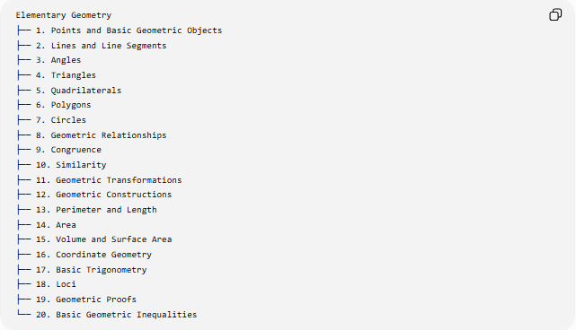
Elementary Geometry
├── 1. Points and Basic Geometric Objects
├── 2. Lines and Line Segments
├── 3. Angles
├── 4. Triangles
├── 5. Quadrilaterals
├── 6. Polygons
├── 7. Circles
├── 8. Geometric Relationships
├── 9. Congruence
├── 10. Similarity
├── 11. Geometric Transformations
├── 12. Geometric Constructions
├── 13. Perimeter and Length
├── 14. Area
├── 15. Volume and Surface Area
├── 16. Coordinate Geometry
├── 17. Basic Trigonometry
├── 18. Loci
├── 19. Geometric Proofs
└── 20. Basic Geometric Inequalities
This is a practical educational classification, rather than one universally fixed taxonomy.

Points and Basic Geometric Objects
# Source: AI Source: Provided by: [Data Path: Persons Table -> ID Column: 1, Name_En Column: Motasem Essam] -> From: [ChatGPT] on [7/20/2026]
Elementary geometry begins with fundamental objects.
Main objects
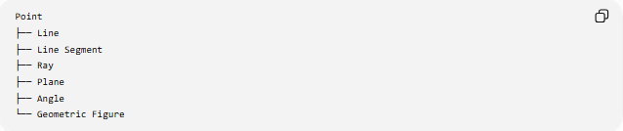
Point
├── Line
├── Line Segment
├── Ray
├── Plane
├── Angle
└── Geometric Figure
Point
A point represents an exact location and has no length, width, or thickness.
Example:
$$A$$
A point can be represented by coordinates:
$$A=\left(3 , 4\right)$$
Line
A line extends infinitely in both directions.
$$\overset{↔}{AB}$$
Segment
A line segment has two endpoints.
$$\overset{‾}{AB}$$
Ray
A ray has one endpoint and extends infinitely in one direction.
$$\vec{AB}$$

Lines and Line Segments
# Source: AI Source: Provided by: [Data Path: Persons Table -> ID Column: 1, Name_En Column: Motasem Essam] -> From: [ChatGPT] on [7/20/2026]
Elementary geometry studies relationships between lines and segments.
Important relationships
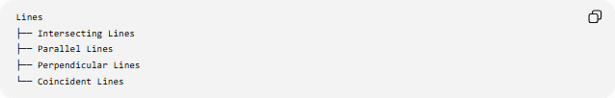
Lines
├── Intersecting Lines
├── Parallel Lines
├── Perpendicular Lines
└── Coincident Lines
Parallel Lines
Two lines that do not intersect in Euclidean geometry.
$$l_{1}∥l_{2}$$
Perpendicular Lines
Two lines that meet at a right angle.
$$l_{1}⊥l_{2}$$
Therefore:
$$m∠={90}^{∘}$$
Segment Addition
If $B$lies between $A$and $C$:
$$AB+BC=AC$$
Example:
$$AB=5, BC=7$$
Therefore:
$$AC=5+7=12$$

Angles
# Source: AI Source: Provided by: [Data Path: Persons Table -> ID Column: 1, Name_En Column: Motasem Essam] -> From: [ChatGPT] on [7/20/2026]
An angle is formed by two rays sharing a common endpoint.
$$∠ABC$$
where $B$is the vertex.
Main Types
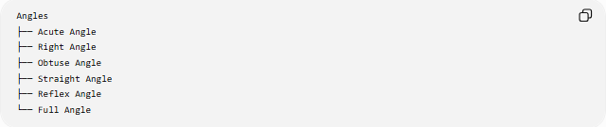
Angles
├── Acute Angle
├── Right Angle
├── Obtuse Angle
├── Straight Angle
├── Reflex Angle
└── Full Angle
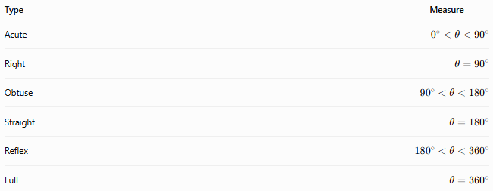
Type | Measure
Acute | $$0^{∘}<θ<{90}^{∘}$$
Right | $$θ={90}^{∘}$$
Obtuse | $${90}^{∘}<θ<{180}^{∘}$$
Straight | $$θ={180}^{∘}$$
Reflex | $${180}^{∘}<θ<{360}^{∘}$$
Full | $$θ={360}^{∘}$$
Example
If:
$$θ={45}^{∘}$$
then $θ$is an acute angle.

Triangles
# Source: AI Source: Provided by: [Data Path: Persons Table -> ID Column: 1, Name_En Column: Motasem Essam] -> From: [ChatGPT] on [7/20/2026]
A triangle is a polygon with three sides and three angles.
$$△ABC$$
Classification by Sides
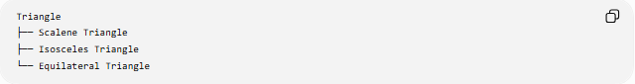
Triangle
├── Scalene Triangle
├── Isosceles Triangle
└── Equilateral Triangle
Classification by Angles
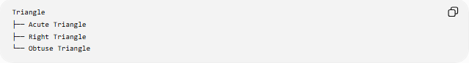
Triangle
├── Acute Triangle
├── Right Triangle
└── Obtuse Triangle
Fundamental Property
The interior angles of every Euclidean triangle sum to:
$$A+B+C={180}^{∘}$$
Example
If:
$$A={50}^{∘}, B={60}^{∘}$$
then:
$$C={180}^{∘}-{50}^{∘}-{60}^{∘} \\ \boxed{C={70}^{∘}}$$
Pythagorean Theorem
For a right triangle:
$$a^{2}+b^{2}=c^{2}$$
Example:
$$a=3, b=4$$
so:
$$c^{2}=3^{2}+4^{2}=25 \\ \boxed{c=5}$$

Quadrilaterals
# Source: AI Source: Provided by: [Data Path: Persons Table -> ID Column: 1, Name_En Column: Motasem Essam] -> From: [ChatGPT] on [7/20/2026]
A quadrilateral is a polygon with four sides.
Main Types
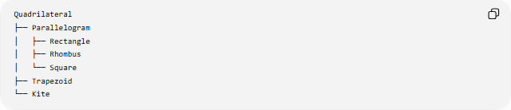
Quadrilateral
├── Parallelogram
│ ├── Rectangle
│ ├── Rhombus
│ └── Square
├── Trapezoid
└── Kite
Rectangle
A rectangle has four right angles.
$$A=B=C=D={90}^{∘}$$
Area:
$$A=lw$$
Square
A square has four equal sides and four right angles.
$$AB=BC=CD=DA$$
Area:
$$A=s^{2}$$
Diagonal:
$$d=s\sqrt{2}$$
Example
For a square with:
$$s=5$$
the area is:
$$A=5^{2}=25$$
and the diagonal is:
$$d=5\sqrt{2}$$

Polygons
# Source: AI Source: Provided by: [Data Path: Persons Table -> ID Column: 1, Name_En Column: Motasem Essam] -> From: [ChatGPT] on [7/20/2026]
A polygon is a closed plane figure formed from finitely many straight-line segments.
Classification by Number of Sides
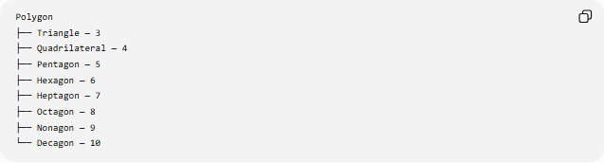
Polygon
├── Triangle — 3
├── Quadrilateral — 4
├── Pentagon — 5
├── Hexagon — 6
├── Heptagon — 7
├── Octagon — 8
├── Nonagon — 9
└── Decagon — 10
Interior Angle Sum
For an $n$-sided polygon:
$$S=\left(n-2\right){180}^{∘}$$
Example: hexagon:
$$S=\left(6-2\right){180}^{∘} \\ \boxed{S={720}^{∘}}$$
For a regular $n$-gon, each interior angle is:
$$\frac{\left(n-2\right){180}^{∘}}{n}$$

Circles
# Source: AI Source: Provided by: [Data Path: Persons Table -> ID Column: 1, Name_En Column: Motasem Essam] -> From: [ChatGPT] on [7/20/2026]
A circle is the set of all points in a plane that are a fixed distance from a fixed point called the center.
If the center is $O$and radius is $r$:
$$OP=r$$
Important Parts
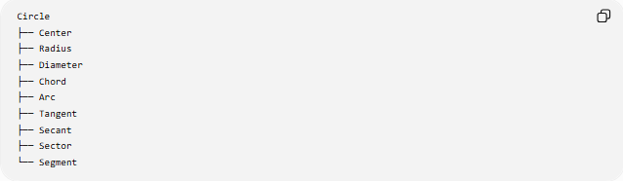
Circle
├── Center
├── Radius
├── Diameter
├── Chord
├── Arc
├── Tangent
├── Secant
├── Sector
└── Segment
Diameter
$$d=2r$$
Circumference
$$C=2πr$$
Area
$$A=πr^{2}$$
Example
For:
$$r=5 \\ C=10π$$
and:
$$A=25π$$

Geometric Relationships
# Source: AI Source: Provided by: [Data Path: Persons Table -> ID Column: 1, Name_En Column: Motasem Essam] -> From: [ChatGPT] on [7/20/2026]
Elementary geometry studies relationships between geometric objects.
Main relationships
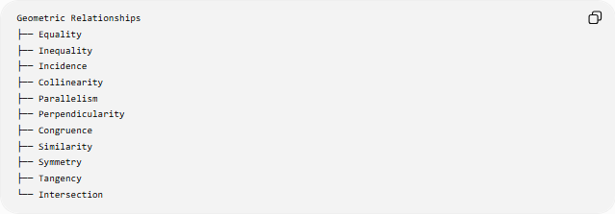
Geometric Relationships
├── Equality
├── Inequality
├── Incidence
├── Collinearity
├── Parallelism
├── Perpendicularity
├── Congruence
├── Similarity
├── Symmetry
├── Tangency
└── Intersection
Example
If:
$$AB=CD$$
then the two segments have equal lengths.
If:
$$l_{1}∥l_{2}$$
the lines are parallel.
If:
$$l_{1}⊥l_{2}$$
the lines are perpendicular.

Congruence
# Source: AI Source: Provided by: [Data Path: Persons Table -> ID Column: 1, Name_En Column: Motasem Essam] -> From: [ChatGPT] on [7/20/2026]
Two geometric figures are congruent when they have the same shape and the same size.
Notation:
$$△ABC≅△DEF$$
Triangle Congruence Criteria
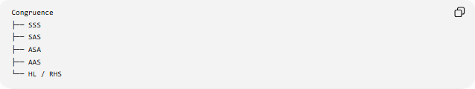
Congruence
├── SSS
├── SAS
├── ASA
├── AAS
└── HL / RHS
For example, SSS means all three corresponding sides are equal.
$$AB=DE \\ BC=EF \\ AC=DF$$
Therefore:
$$△ABC≅△DEF$$

Similarity
# Source: AI Source: Provided by: [Data Path: Persons Table -> ID Column: 1, Name_En Column: Motasem Essam] -> From: [ChatGPT] on [7/20/2026]
Two figures are similar when they have the same shape but may have different sizes.
Notation:
$$△ABC∼△DEF$$
Corresponding angles are equal and corresponding lengths are proportional.
$$\frac{AB}{DE}=\frac{BC}{EF}=\frac{AC}{DF}=k$$
where $k$is the scale factor.
Example
A triangle has sides:
$$3, 4, 5$$
A similar triangle has scale factor $2$, so its sides are:
$$6, 8, 10$$

Geometric Transformations
# Source: AI Source: Provided by: [Data Path: Persons Table -> ID Column: 1, Name_En Column: Motasem Essam] -> From: [ChatGPT] on [7/20/2026]
A transformation maps points of a figure to new positions.
Main Types
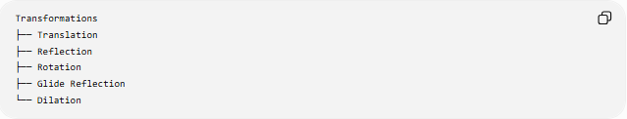
Transformations
├── Translation
├── Reflection
├── Rotation
├── Glide Reflection
└── Dilation
Translation
Moves every point the same distance and direction.
$$\left(x , y\right)→\left(x , +ay+b\right)$$
Example:
$$\left(x , y\right)→\left(x , +3y+2\right)$$
Reflection
Produces a mirror image.
Reflection across the $x$-axis:
$$\left(x , y\right)→\left(x , -y\right)$$
Rotation
Turns a figure around a center.
A ${90}^{∘}$counterclockwise rotation about the origin:
$$\left(x , y\right)→\left(- , yx\right)$$
Dilation
Changes size while preserving shape.
$$\left(x , y\right)→\left(k , xky\right)$$

Geometric Constructions
# Source: AI Source: Provided by: [Data Path: Persons Table -> ID Column: 1, Name_En Column: Motasem Essam] -> From: [ChatGPT] on [7/20/2026]
Geometric construction is the process of creating geometric objects using idealized tools and exact procedures.
Traditionally:
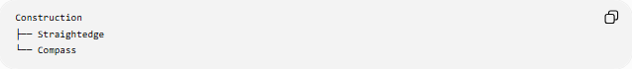
Construction
├── Straightedge
└── Compass
Common Constructions
- Constructing a perpendicular bisector
- Constructing an angle bisector
- Constructing a perpendicular line
- Constructing a parallel line
- Copying an angle
- Dividing a segment
- Constructing special triangles
Example
To construct the perpendicular bisector of $AB$:
- Draw equal-radius arcs centered at $A$and $B$.
- Let the arcs intersect at $P$and $Q$.
- Draw $\overset{‾}{PQ}$.
- Then:
$$PQ⊥AB$$
and:
$$AM=MB$$
where $M=PQ∩AB$.

Perimeter and Length
# Source: AI Source: Provided by: [Data Path: Persons Table -> ID Column: 1, Name_En Column: Motasem Essam] -> From: [ChatGPT] on [7/20/2026]
Elementary geometry measures lengths of segments and boundaries.
Perimeter
The perimeter is the total length around a closed figure.
For a rectangle:
$$P=2l+2w$$
For a triangle:
$$P=a+b+c$$
For a square:
$$P=4s$$
Example
Rectangle:
$$l=8, w=3 \\ P=2\left(8\right)+2\left(3\right)=22$$

Area
# Source: AI Source: Provided by: [Data Path: Persons Table -> ID Column: 1, Name_En Column: Motasem Essam] -> From: [ChatGPT] on [7/20/2026]
Area measures the amount of two-dimensional region occupied by a figure.
Important Formulas
Triangle:
$$A=\frac{1}{2}bh$$
Rectangle:
$$A=lw$$
Square:
$$A=s^{2}$$
Parallelogram:
$$A=bh$$
Trapezoid:
$$A=\frac{1}{2}\left(a+b\right)h$$
Circle:
$$A=πr^{2}$$
Example
Triangle with:
$$b=10, h=6$$
has area:
$$A=\frac{1}{2}\left(10\right)\left(6\right)=30$$

Volume and Surface Area
# Source: AI Source: Provided by: [Data Path: Persons Table -> ID Column: 1, Name_En Column: Motasem Essam] -> From: [ChatGPT] on [7/20/2026]
Elementary geometry also introduces basic three-dimensional measurement.
Common Solids
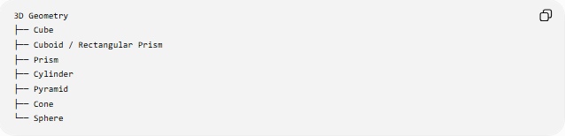
3D Geometry
├── Cube
├── Cuboid / Rectangular Prism
├── Prism
├── Cylinder
├── Pyramid
├── Cone
└── Sphere
Cube
$$V=s^{3}$$
Rectangular Prism
$$V=lwh$$
Cylinder
$$V=πr^{2}h$$
Sphere
$$V=\frac{4}{3}πr^{3}$$
Surface area of a sphere:
$$SA=4πr^{2}$$
Example
A cube with:
$$s=4$$
has:
$$V=4^{3}=64$$

Coordinate Geometry
# Source: AI Source: Provided by: [Data Path: Persons Table -> ID Column: 1, Name_En Column: Motasem Essam] -> From: [ChatGPT] on [7/20/2026]
Coordinate geometry represents geometric objects using numbers and coordinates.
A point in the plane can be written:
$$P=\left(x , y\right)$$
Distance Formula
For:
$$A=\left(x_{1} , y_{1}\right), B=\left(x_{2} , y_{2}\right) \\ AB=\sqrt{{\left(x_{2}-x_{1}\right)}^{2}+{\left(y_{2}-y_{1}\right)}^{2}}$$
Midpoint
$$M=\left(\frac{x_{1}+x_{2}}{2} , \frac{y_{1}+y_{2}}{2}\right)$$
Example
For:
$$A=\left(0 , 0\right), B=\left(3 , 4\right) \\ AB=\sqrt{3^{2}+4^{2}}=5$$

Basic Trigonometry
# Source: AI Source: Provided by: [Data Path: Persons Table -> ID Column: 1, Name_En Column: Motasem Essam] -> From: [ChatGPT] on [7/20/2026]
Elementary geometry commonly introduces trigonometric relationships through right triangles.
For angle $θ$:
$$\sin{θ}=\frac{\text{opposite}}{\text{hypotenuse}} \\ \cos{θ}=\frac{\text{adjacent}}{\text{hypotenuse}} \\ \tan{θ}=\frac{\text{opposite}}{\text{adjacent}}$$
Example
For a right triangle with:
- opposite $=3$
- adjacent $=4$
- hypotenuse $=5$
$$\sin{θ}=\frac{3}{5} \\ \cos{θ}=\frac{4}{5} \\ \tan{θ}=\frac{3}{4}$$

Loci
# Source: AI Source: Provided by: [Data Path: Persons Table -> ID Column: 1, Name_En Column: Motasem Essam] -> From: [ChatGPT] on [7/20/2026]
A locus is the set of all points satisfying a specified geometric condition.
Examples
Fixed distance from $A$:
$$PA=r$$
produces a circle centered at $A$.
Equal distance from $A$and $B$:
$$PA=PB$$
produces the perpendicular bisector of $AB$.
Fixed distance from a line:
$$d\left(P , l\right)=r$$
produces two lines parallel to $l$.
A fixed-angle condition:
$$∠APB=θ$$
produces appropriate circular arcs through $A$and $B$.

Geometric Proofs
# Source: AI Source: Provided by: [Data Path: Persons Table -> ID Column: 1, Name_En Column: Motasem Essam] -> From: [ChatGPT] on [7/20/2026]
A geometric proof establishes that a geometric statement is true using definitions, axioms, postulates, previously proven theorems, and logical reasoning.
General structure:
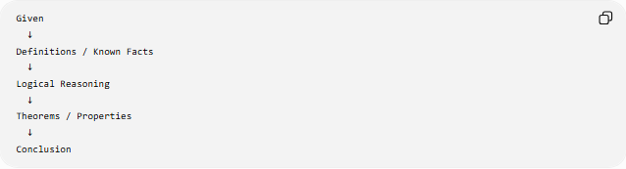
Given
↓
Definitions / Known Facts
↓
Logical Reasoning
↓
Theorems / Properties
↓
Conclusion
Example
Given $AB=AC$in $△ABC$.
Then the triangle is isosceles, so the opposite angles are equal:
$$∠B=∠C$$
This is an example of deductive geometric reasoning.

Basic Geometric Inequalities
# Source: AI Source: Provided by: [Data Path: Persons Table -> ID Column: 1, Name_En Column: Motasem Essam] -> From: [ChatGPT] on [7/20/2026]
Elementary geometry also studies comparisons between geometric quantities.
Triangle Inequality
For triangle sides $a,b,c$:
$$a+b>c \\ a+c>b \\ b+c>a$$
Equivalent form:
$$∣a-b∣<c<a+b$$
Example
Can $3,4,8$be the sides of a triangle?
Check:
$$3+4>8 \\ 7>8$$
which is false.
Therefore, 3, 4, and 8 cannot form a triangle.

Important Theorems in Elementary Geometry
# Source: AI Source: Provided by: [Data Path: Persons Table -> ID Column: 1, Name_En Column: Motasem Essam] -> From: [ChatGPT] on [7/20/2026]
Some fundamental theorems include:
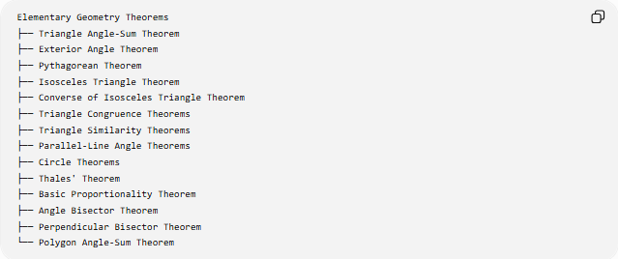
Elementary Geometry Theorems
├── Triangle Angle-Sum Theorem
├── Exterior Angle Theorem
├── Pythagorean Theorem
├── Isosceles Triangle Theorem
├── Converse of Isosceles Triangle Theorem
├── Triangle Congruence Theorems
├── Triangle Similarity Theorems
├── Parallel-Line Angle Theorems
├── Circle Theorems
├── Thales' Theorem
├── Basic Proportionality Theorem
├── Angle Bisector Theorem
├── Perpendicular Bisector Theorem
└── Polygon Angle-Sum Theorem
These form much of the foundation for more advanced geometry.

Elementary Geometry vs Advanced Geometry
# Source: AI Source: Provided by: [Data Path: Persons Table -> ID Column: 1, Name_En Column: Motasem Essam] -> From: [ChatGPT] on [7/20/2026]
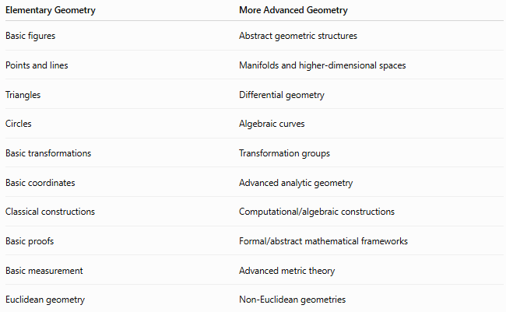

Elementary Geometry | More Advanced Geometry
Basic figures | Abstract geometric structures
Points and lines | Manifolds and higher-dimensional spaces
Triangles | Differential geometry
Circles | Algebraic curves
Basic transformations | Transformation groups
Basic coordinates | Advanced analytic geometry
Classical constructions | Computational/algebraic constructions
Basic proofs | Formal/abstract mathematical frameworks
Basic measurement | Advanced metric theory
Euclidean geometry | Non-Euclidean geometries
Elementary geometry is therefore best viewed as a foundation, not as a completely separate mathematical universe.

Relationship to Euclidean Geometry
# Source: AI Source: Provided by: [Data Path: Persons Table -> ID Column: 1, Name_En Column: Motasem Essam] -> From: [ChatGPT] on [7/20/2026]
Elementary geometry is strongly associated with Euclidean geometry, especially when studying ordinary flat-plane geometry.
A typical hierarchy is:
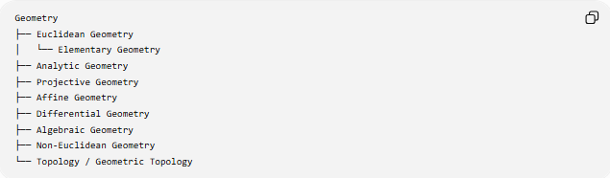
Geometry
├── Euclidean Geometry
│ └── Elementary Geometry
├── Analytic Geometry
├── Projective Geometry
├── Affine Geometry
├── Differential Geometry
├── Algebraic Geometry
├── Non-Euclidean Geometry
└── Topology / Geometric Topology
However, these categories overlap. Elementary geometry is primarily an educational/foundational level of geometry, while Euclidean geometry describes a particular geometric framework.

Classification Summary
# Source: AI Source: Provided by: [Data Path: Persons Table -> ID Column: 1, Name_En Column: Motasem Essam] -> From: [ChatGPT] on [7/20/2026]
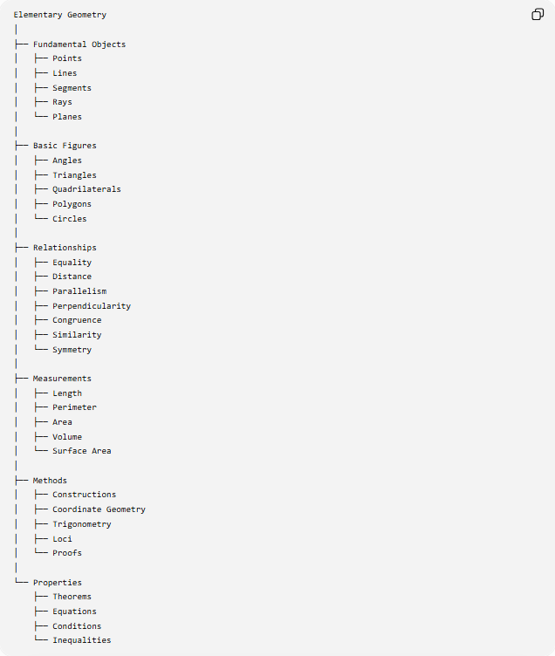
Elementary Geometry
│
├── Fundamental Objects
│ ├── Points
│ ├── Lines
│ ├── Segments
│ ├── Rays
│ └── Planes
│
├── Basic Figures
│ ├── Angles
│ ├── Triangles
│ ├── Quadrilaterals
│ ├── Polygons
│ └── Circles
│
├── Relationships
│ ├── Equality
│ ├── Distance
│ ├── Parallelism
│ ├── Perpendicularity
│ ├── Congruence
│ ├── Similarity
│ └── Symmetry
│
├── Measurements
│ ├── Length
│ ├── Perimeter
│ ├── Area
│ ├── Volume
│ └── Surface Area
│
├── Methods
│ ├── Constructions
│ ├── Coordinate Geometry
│ ├── Trigonometry
│ ├── Loci
│ └── Proofs
│
└── Properties
├── Theorems
├── Equations
├── Conditions
└── Inequalities

Key Formulas
# Source: AI Source: Provided by: [Data Path: Persons Table -> ID Column: 1, Name_En Column: Motasem Essam] -> From: [ChatGPT] on [7/20/2026]
Lines and Distance
$$AB=\sqrt{{\left(x_{2}-x_{1}\right)}^{2}+{\left(y_{2}-y_{1}\right)}^{2}}$$
Midpoint
$$M=\left(\frac{x_{1}+x_{2}}{2} , \frac{y_{1}+y_{2}}{2}\right)$$
Triangle
$$A+B+C={180}^{∘} \\ A=\frac{1}{2}bh \\ a^{2}+b^{2}=c^{2}$$
Rectangle
$$A=lw \\ P=2\left(l+w\right)$$
Square
$$A=s^{2} \\ P=4s \\ d=s\sqrt{2}$$
Circle
$$C=2πr \\ A=πr^{2} \\ d=2r$$
Polygon
$$S=\left(n-2\right){180}^{∘}$$
Cylinder
$$V=πr^{2}h$$
Sphere
$$V=\frac{4}{3}πr^{3} \\ SA=4πr^{2}$$

Key Points
# Source: AI Source: Provided by: [Data Path: Persons Table -> ID Column: 1, Name_En Column: Motasem Essam] -> From: [ChatGPT] on [7/20/2026]
- Elementary Geometry studies fundamental geometric objects, figures, measurements, and relationships.
- It focuses heavily on Euclidean geometry.
- Its fundamental objects include points, lines, segments, rays, angles, and planes.
- Major figures include triangles, quadrilaterals, polygons, and circles.
- It introduces fundamental concepts of congruence, similarity, symmetry, transformations, and loci.
- It provides basic methods of construction, coordinate geometry, trigonometry, and proof.
- It establishes many of the fundamental formulas and theorems used throughout geometry.
- Elementary geometry provides the foundation for more advanced areas such as analytic, projective, affine, differential, algebraic, and non-Euclidean geometry.

Conclusion
# Source: AI Source: Provided by: [Data Path: Persons Table -> ID Column: 1, Name_En Column: Motasem Essam] -> From: [ChatGPT] on [7/20/2026]
Elementary Geometry is the foundational study of basic geometric objects, shapes, measurements, properties, and relationships. It develops the core language and reasoning of geometry through points, lines, angles, triangles, polygons, circles, transformations, constructions, coordinates, loci, proofs, and measurements. These concepts form the foundation upon which more advanced branches of geometry are built.

